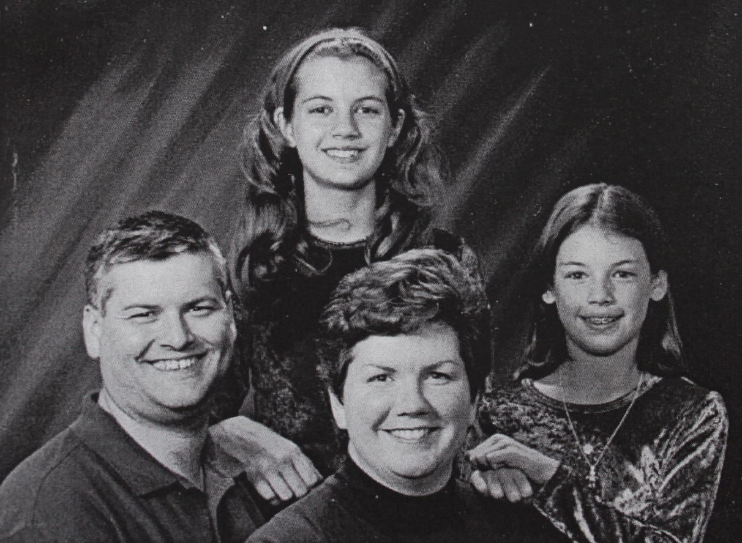

Doug Raasch, Sarah Raasch, Mary Jo Lyons Raasch, Melinda Raasch – about 2000



Sara Raasch, author of Snow Like Ashes – 2013